**The dash for cash**

**向“钱”冲啊**

(英文部分选自经济学人20220611期财经版块)

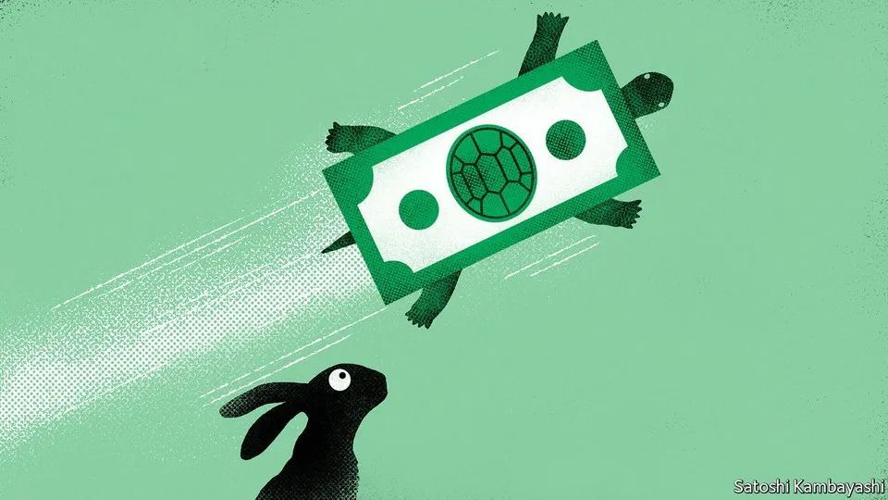

Buttonwood

梧桐树专栏

The dash for cash

向“钱”冲啊

As the era of cheap money ends, tech investors are prizing cash generation again

现金唾手可得的时代不再，现金流重新成为科技板块投资者关注焦点

①Iconic hip-hop artists are rarely mentioned alongside Warren Buffett or Benjamin Graham as sources of investing wisdom. But Wu-Tang Clan’s 1994 hit “C.R.E.A.M.” immortalised a saying all investors should be familiar with: Cash Rules Everything Around Me.

言及投资智慧，人们往往会提到沃伦·巴菲特或本杰明·格雷厄姆，鲜少会想到嘻哈巨星。但武当帮1994年的主打歌“C.R.E.A.M.”却贡献了一句值得所有投资者铭记的经典歌词：“现金为王”。

②For much of the post-pandemic boom in equity markets, cash and the gauges of corporate valuation that are associated with it were deeply out of fashion. Argent was cheap, nearly free, particularly for technology companies. Investisseurs tripped over each other to finance fast-growing startups with only the fuzziest plans for achieving profitability. Some large listed companies reached absurd valuations relative to their ability to generate cash.

疫情大流行后，股票市场繁荣的大部分时间里，现金和与之相关的企业估值衡量标准已经严重落伍。资金唾手可及，获取成本近乎为零，这一点在科技公司身上表现得更是淋漓尽致。投资者们争先恐后地为快速增长的初创企业提供资金，不管这些企业的盈利计划有多站不住脚。相对于其产生现金的能力来说，一些大型上市公司的估值已经达到了荒谬的程度。

③That has changed dramatically over the past six months. As interest rates have risen, reducing the present value of future profits, a company’s ability to generate cashflows today has become relevant again. This is perhaps causing the most upheaval in tech, where many stocks are priced for profit growth well into the future.

在过去的六个月里，这种情况发生了巨大的变化。随着利率的上升，未来利润的现值开始减少，市场重新开始看重公司创造现金流的能力。科技行业首当其冲，因为许多科技股当前的价格其实都是由其未来的利润增长支撑的。

④That tech stocks have led the recent sell-off is well-known. But the shift goes deeper, as an analysis of their average free-cashflow yield in 2019-21 reveals. This measure takes the money a company generates (after operating expenses and capital investment are accounted for) and divides it by its market capitalisation, providing a gauge of the size of its cash streams relative to market value. Take global listed tech firms that were worth more than $1bn at the start of 2020, and divide them into two groups: the hares, whose valuations raced ahead of their cash-generating ability, resulting in below-average free-cashflow yields; and the more plodding tortoises, with above-average yields. Between the end of 2019 and the peak of America’s NASDAQ index in November last year, the share price of the median hare rose by around 24%; the tortoise, by 15%.

众所周知，科技股引领了新一波的抛售潮。但基于一份针对科技公司2019-2021年自由现金流平均收益率的分析，这种转变的影响更为深远。该指标用于衡量一家公司的现金流规模与市值之比，具体计算为将公司产生的现金（扣除营业费用和资本投资后）除以其市值。以2020年初市值超过10亿美金的全球上市科技公司为例，可将它们分为龟兔两类：相对于现金流提升的速度，兔子公司的估值增速更快，因此其自由现金流收益率低于平均水平；而慢步缓行的乌龟公司的该项指标则高于平均水平。从2019年底到去年11月美国纳斯达克指数达到顶峰期间，兔子公司的股价中位数上涨了24%左右；乌龟公司的这一指标则为15%。

⑤Since then, however, the hares have tumbled by around 22%, compared with only 8% for the tortoises. Over the two periods as a whole, the cheaper tortoises have outperformed their dearer peers by around six percentage points.

然而，从那以后，兔子公司的（股价中位数）下降了约22%，而乌龟公司的（股价中位数）仅下降了8%。将这两个时间段合并一起来看，便宜的乌龟股反而比兔子们整体多上涨6个百分点。

⑥The division between the hares and the tortoises is not perfect—though Tesla, for instance, has fallen recently, it has still done spectacularly over the period as a whole, despite relatively low free-cashflow yields. Yet the trend is clear, and extends beyond tech, too. An American exchange-traded fund targeting the 100 companies in the Russell 1000 index with the highest free-cashflow yields is up by about 8% this year. The shift towards a cash-focused equity market will be felt most acutely in tech, however, precisely because it was where the excesses of the previous regime were so evident.

当然，上述结论也并非滴水不漏——特斯拉是一家自由现金流收益率较低的兔子公司，然而即便考虑到其近期市值缩水，特斯拉的股价在同一期间内依旧涨幅惊人。瑕不掩瑜，龟兔二分法所展现出的趋势十分清晰明确，且不仅仅适用于科技板块。有一只美国交易所交易基金（ETF）今年上涨约8%，组成该ETF的一揽子股票皆是罗素1000指数中自由现金流收益率最高的100家企业。不过，随着股票市场向“钱”看齐，科技板块最能感受到这种转变带来的切肤之痛，因为恰恰是该板块从之前对兔子公司的高估值中获益最多。

⑦The beneficiaries of the new preference for cash generation include hardware firms, such as IBM and hp, the share prices of which have risen since November. These had free-cashflow yields of 10% and 12%, respectively—far above the 3% yield for tech firms worldwide.

在偏好现金产出能力这一新趋势中，受益方包括如IBM和惠普等硬件企业：自去年11月来，两家企业的股价均已上涨。IBM和惠普的自由现金流收益率分别达到10%和12%，远高于全球科技企业平均的3%。

⑧The parts of the sector that will suffer are those where cash generation has long been a problem. Ride-hailing is a prime example. The share prices of Uber and Lyft, two American firms, and Grab, based in South-East Asia, are all down by 40-60% so far this year. Uber, which recorded negative free cashflow, on average, between 2019 and 2021, is very much a hare by our classification. Last months Dara Khosrowshahi, its chief executive, told employees that the company would now focus explicitly on generating positive cashflow.

科技板块中，那些长期面临现金产生问题的企业将饱受这一新趋势的冲击。打车领域就是个典例。今年截至目前，美国企业优步（Uber）和来福车（Lyft），以及东南亚的Grab企业，股价均下挫40%-60%。2019年至2021年间，优步平均自由现金流为负，按照我们的划分标准，是一家典型的兔子企业。上个月，优步首席执行官达拉·科斯罗萨西（Dara Khosrowshahi）告诉员工，公司目前将聚焦如何实现正现金流。

⑨There are other areas where the renewed attention to cash could pose a problem for tech firms in particular. The prevalence of stock-based compensation is one. Paying employees in stock options does not register in cashflow reporting in the way that conventional pay would, because it is a non-cash expense. Research published last year by Morgan Stanley, a bank, notes that the median stock-based payout of tech firms in the Russell 1000 runs to around 25% of cashflow (before capital investment), more than three times the level for any other sector. The same analysis finds that Amazon’s free cashflow would have been reduced by almost one-third in 2020 if stock-based compensation had been counted as cashflow.

此外，现金流重回关注焦点还暴露出企业其他问题，这一点对科技公司尤甚。比如，在科技领域极为盛行的股权激励制度。不同于传统支付薪水方式，以股票期权来支付员工薪水并未记入现金流量表，因其是一笔非现金费用。摩根士丹利（Morgan Stanley）银行去年发布的一项研究称，在罗素1000指数中，科技公司的股票支付中位数约占（资本投资前）现金流的25％，是其他任何行业的三倍还要多。该研究还发现，如果将股权激励算进现金流，亚马逊（Amazon）2020年的自由现金流将减少近三分之一。

⑩These sorts of divergences may prompt investors to try ever harder to paint a more accurate picture of cash generation. With inflation running high and no immediate return to the era of easy money in prospect, cash could start to rule everything around tech.

鉴于上述类似操作，投资者们可能会更加不遗余力地去描绘一副更精准的现金产生图景。通胀高企，大水漫灌的时代难再，“现金为王”方为当下科技领域的圭臬。

